Chapter 19, Problem 9.

The y parameters of a network are:

Y 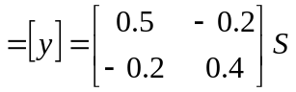

Determine the z parameters for the network.

